# Tools, Implementation methods

## Metaverse marketing tools are reshaping advertising

Metaverse Marketing is revolutionizing the traditional advertising playbook. These innovative tools are reshaping advertising, giving marketers powerful ways to capture audiences and drive success for brands in the digital age.

### Immersive Storytelling with VR and AR

Metaverse Marketing tools use the immersive capabilities provided by VR and AR in order to allow brands to tell their stories in a way that was never possible before. Interactive storytelling transports the audience into a virtual world where they can become active participants. This innovative approach to storytelling creates memorable brand experiences.

### Dynamic Ad formats for enhanced engagement

Metaverse is a place where dynamic and interactive formats are replacing static ads. Brands can create engaging campaigns by incorporating clickable 3D ads and gamified ads. These dynamic ad formats not only entertain, but also increase interaction rates. This leads to an increased brand recognition and customer engagement.

### Virtual Try-On Experiences of Products

Metaverse Marketing Tools enable virtual try-ons for products in fashion and beauty. Users can virtually try-on clothing, accessories or makeup to enhance their online shopping experience. It not only helps to reduce the fear of online shopping, but it also allows consumers to interact with products and have fun

### AI-Powered Personalization for Ad Targeting

Metaverse Marketing’s tools are a great example of how artificial intelligence (AI), which offers advanced personalization, can be used to enhance ad targeting. AI algorithms analyze user behaviors, preferences and interactions in order to deliver ads that are tailored to individual interests. This personalization increases the relevance of advertisements, leading to higher rates of conversion and a happier audience.

### Integrating Blockchain and NFT for Authenticity

Metaverse Marketing uses blockchain technology to create non-fungible (NFT) tokens that ensure the authenticity and ownership of digital assets. Brands can create limited-edition items or virtual experiences using NFTs, creating a sense of exclusivity. This integration adds value to digital assets and creates a secure, transparent framework for digital transactions in the Metaverse.

### Real-Time analytics for agile campaign optimization

Metaverse Marketing provides real-time analytics that allow marketers to track the performance of their campaigns and make adjustments immediately. Brands can take advantage of this agility to optimize their campaigns, respond quickly to user interaction, and capitalize on emerging trends.

## Metaverse Tools for Enhancing User Engagement

User engagement is a key success metric in the digital marketing landscape. The focus on creating meaningful experiences is increasing as businesses navigate the Metaverse. Metaverse Tools are essential for enhancing user engagement and offer innovative ways to connect brands with their audience.

### Immersive Virtual Spaces

Metaverse Tools allow the creation of immersive virtual environments where users can interact in a 3-D environment with brands. These spaces, which include virtual storefronts and branded experiences as well, transcend traditional online platforms. They give users a sense that they are present, and engage with brands beyond the screen.

### Interactive Product Showcases

Metaverse Tools are known for their ability to turn product displays into interactive experiences. Users can virtually interact and explore products to gain a deeper understanding of them before making a purchase decision. This dynamic approach increases user engagement by making shopping not only transactional, but also experiential.

### Personalized Avatars & Brand Interaction

Metaverse Tools let users create their own avatars and bridge the gap between virtual and real life. Brands can engage their users by offering them personalized recommendations, exclusive contents, and interactive experiences. This personalized interaction creates a feeling of loyalty and connection among users.

### 7.4. Socializing in Virtual Communities

Metaverse experiences are community-driven, and go beyond the individual interaction. Brands can host virtual conferences, social gatherings or events to create a community of users. These virtual communities allow users to not only interact with the brand, but also with other like-minded people. This enhances the overall user experience.

### Gamification Strategies

Metaverse Tools integrates gaming elements seamlessly into marketing strategies. Gamification can be a powerful tool for increasing user engagement. Brands can create games, challenges or quests that encourage users to participate actively and receive rewards. Gamification adds a fun element to the experience, which keeps users interested and engaged in your brand.

### Real-time collaboration and co-creation

Metaverse Tools allow for real-time collaboration and co-creation between brands and their users. Users can actively participate in the brand narrative by influencing product developments or taking part in virtual events. This collaborative approach strengthens engagement, but empowers the users as they become active participants in the journey of a brand.

## Metaverse Marketing: Integrating AR and VR for Immersive Advertising

In the Metaverse, the fusion of Augmented Reality and Virtual Reality has created a new age of immersive advertising. This section will examine the role of AR and VR in Metaverse Marketing.

### The Impact of Augmented Reality on Marketing: Bridging Real and Virtual

Augmented Reality (AR) overlays digital content on the real world seamlessly merging the virtual and physical realms. AR is used in Metaverse Marketing to enhance user experience by allowing users to interact with services and products within their immediate surroundings. This innovative marketing approach bridges the divide between the real world and the virtual one, creating an engaging and dynamic advertising landscape.

### Virtual Reality and the Creation of Virtual Worlds – A 360 Degree Experience

Virtual Reality, however, immerses the user in a digital environment. Metaverse Marketing uses VR to give consumers a 360° experience. They can engage with brands, explore virtual worlds, and interact on a deeply immersive level. This level of immersiveness goes beyond traditional marketing methods and leaves a lasting impression on the audience.

### Bring products to life with interactive product visualization

Metaverse Marketing’s ability to integrate AR and VR into its marketing strategy has many advantages, including the interactive visualization of products. Virtually “trying on” products is possible, as well as visualizing furniture in the home or driving virtual versions of cars. It not only improves the shopping experience, but it also helps in making better decisions by fostering a connection with the product or service being offered.

### Gamification of Advertising: Making Brands Playable

With the integration of AR and VR, Gamification becomes an even more powerful tool for Metaverse Marketing. Brands can turn their marketing strategies and campaigns into interactive experiences that make advertising fun for the users. This is a great way to not only grab attention, but also encourage active participation. It leaves a lasting impression on your audience.

### Immersive experiences enhance storytelling

AR and VR allow brands to tell their stories in previously unimaginable ways. Immersive stories allow users to become active participants of the brand story. The combination of AR/VR elevates storytelling, whether it’s through exploring the history of the product, participating in interactive narratives or embarking on virtual adventures.

### Virtual Try Before You Buy: Overcome Physical Limitations

The inability to physically experience a product prior to purchase is a major challenge for traditional retail. Metaverse Marketing addresses this problem by providing virtual try-before you-buy experiences. Users can virtually try on clothes, test out cosmetics or visualize home décor items in their homes, giving them a confidence that traditional advertising methods cannot achieve.

# Metavers in Iran

As we mentioned, in the same year, 2021, the Metaverse idea also became a trend in Iran. This popularity was to the extent that on some domestic online advertising platforms, ads for land sales in the Metaverse were noticeable. However, the advertisers of these ads were mostly looking for some kind of brokerage for buying and selling virtual items available on decentralized platforms like Decentraland and Sandbox.

As it appears from the situation, most of these ads had a brokerage aspect. That is, some who had previous experience in buying and selling land and other virtual items in Decentraland and Sandbox would advise those who had less knowledge in this area. Or they would act as intermediaries on their behalf to buy land on these platforms.

It should be noted that some of these platforms removed articles related to buying and selling land in the Metaverse or investing in the Metaverse from their ad listings after a few days.



In recent years, the Metaverse in Iran has been in a growing state. From the year 2021 to the present, numerous domestic and international Metaverse events have been held in Iran. Additionally, many companies and organizations have taken steps to educate about the Metaverse and hold training courses and webinars. An association named the "Iran Metaverse Association" was formed in the year 2021, and Iranian Metaverse enthusiasts began their activities.

The first Iranian Metaverse project was called KishVR. KishVR was the result of collaboration between developers from Iran and Qatar. This Metaverse was designed inspired by Kish Island and had three layers:

1. The first layer, or the beachfront strip, which was dedicated to recreational club establishments.

2. The second layer, which was allocated to commercial buildings.

3. The third layer, which was for more strategic structures such as airports.

Also there is another startup called Metarangh, working on virtuall reality and design Iran palaces in VR

Where people can make character and explore the virtual world which comes from culture of Iran.

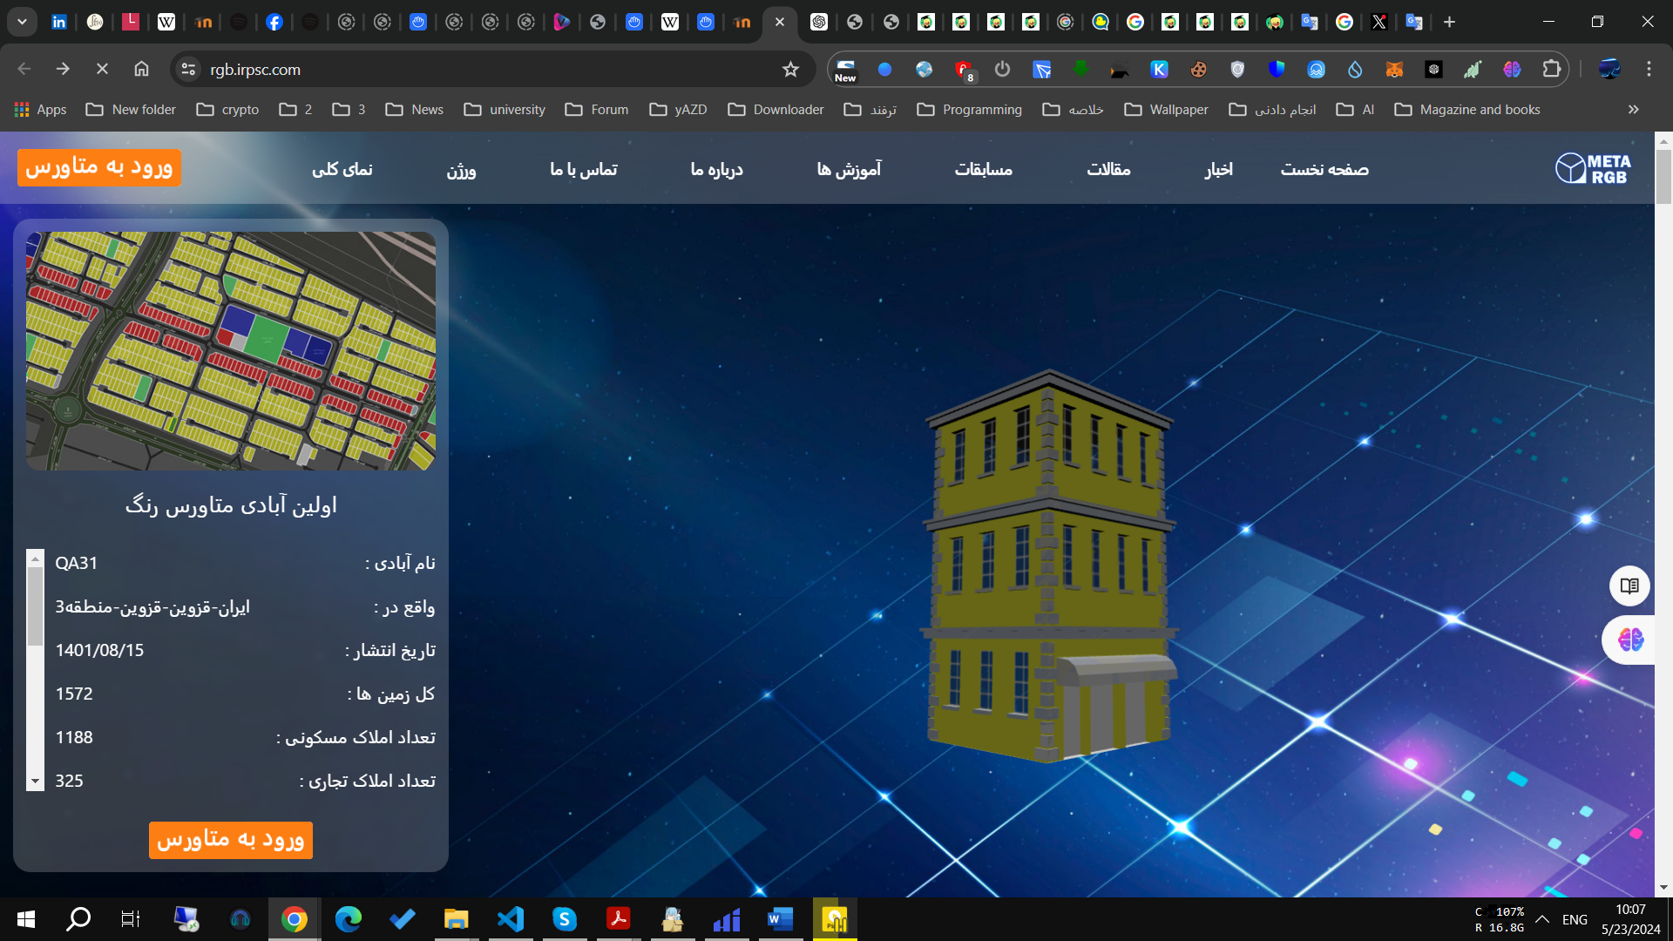

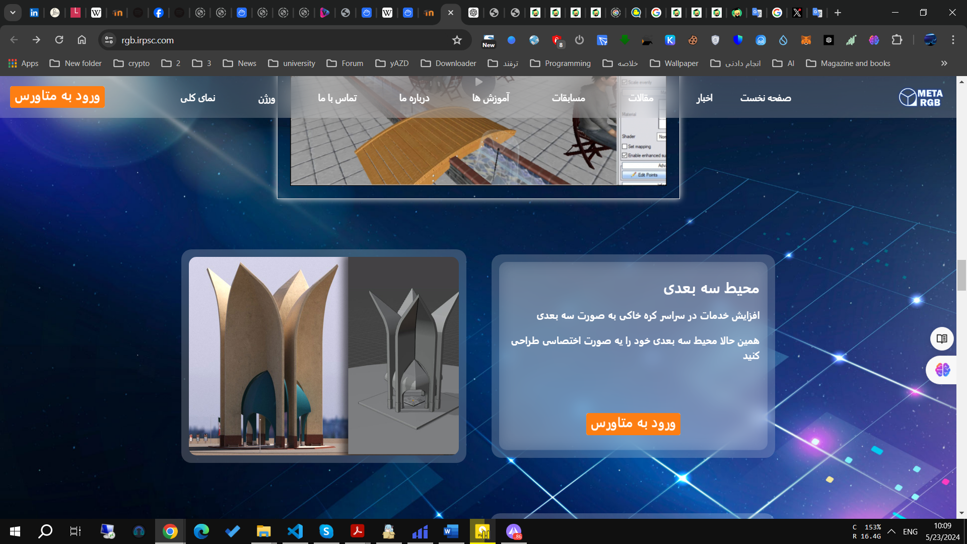

However, it's worth noting that the history of the Metaverse globally and in Iran is longer. Some consider the Metaverse as synonymous with virtual reality. This definition is not entirely incorrect. The truth is that the Metaverse in its initial state is indeed virtual reality or VR. With this definition, the first entry of the Metaverse into Iran was through virtual reality games.

# Refrecses

<https://blog.emb.global/metaverse-marketing-tools-a-review/>

https://www.ediiie.com/blog/metaverse-marketing-strategies-and-examples/

https://pixelplex.io/blog/marketing-in-the-metaverse/

<https://sdlccorp.com/post/metaverse-marketing-stratergies/>

<https://arzdigital.com/metaverse-in-iran/>

<https://rgb.irpsc.com/>